**Lab Exercise - 1**

Name – Harsh Vardhan Kushwaha

Reg. No. – 17BCN7017

1. Insert the data given in employee, department and project tables.

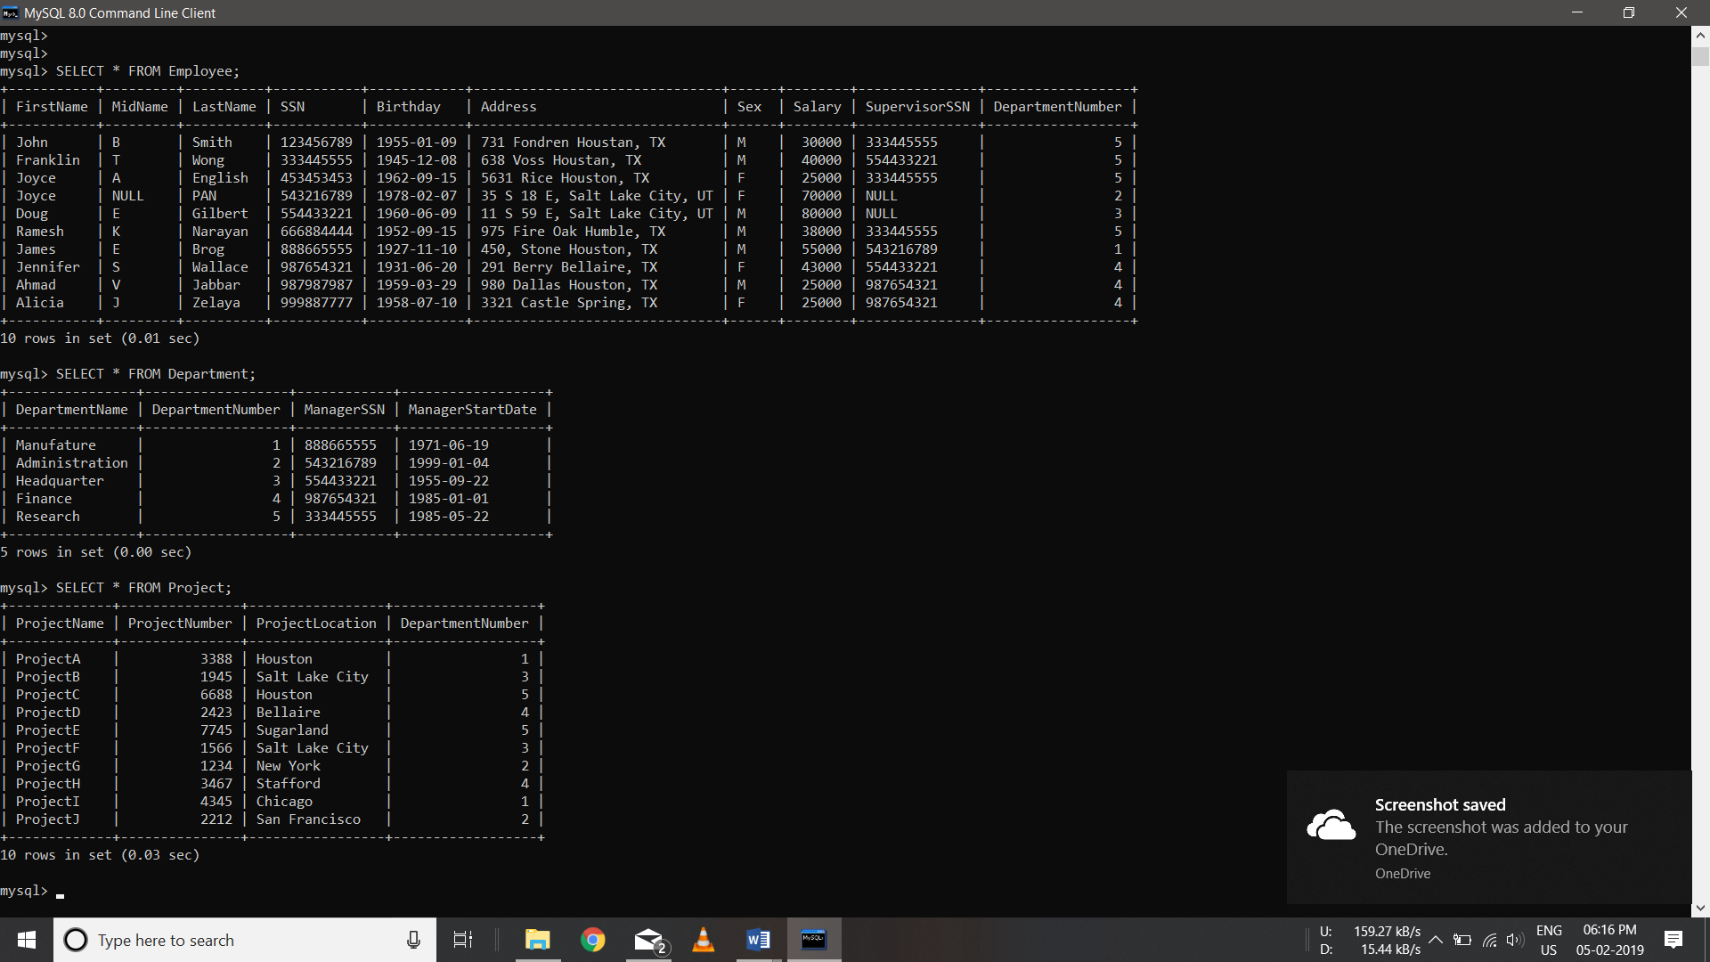

1. Display all the employees’ information.

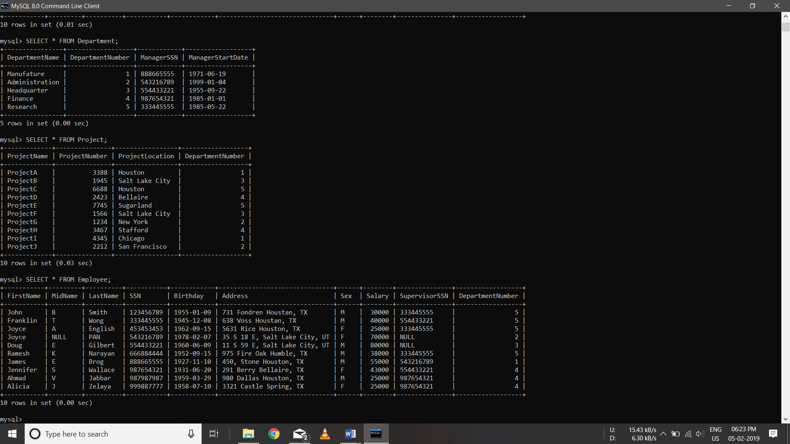

1. Display employee name along with his SSN and Supervisor SSN.

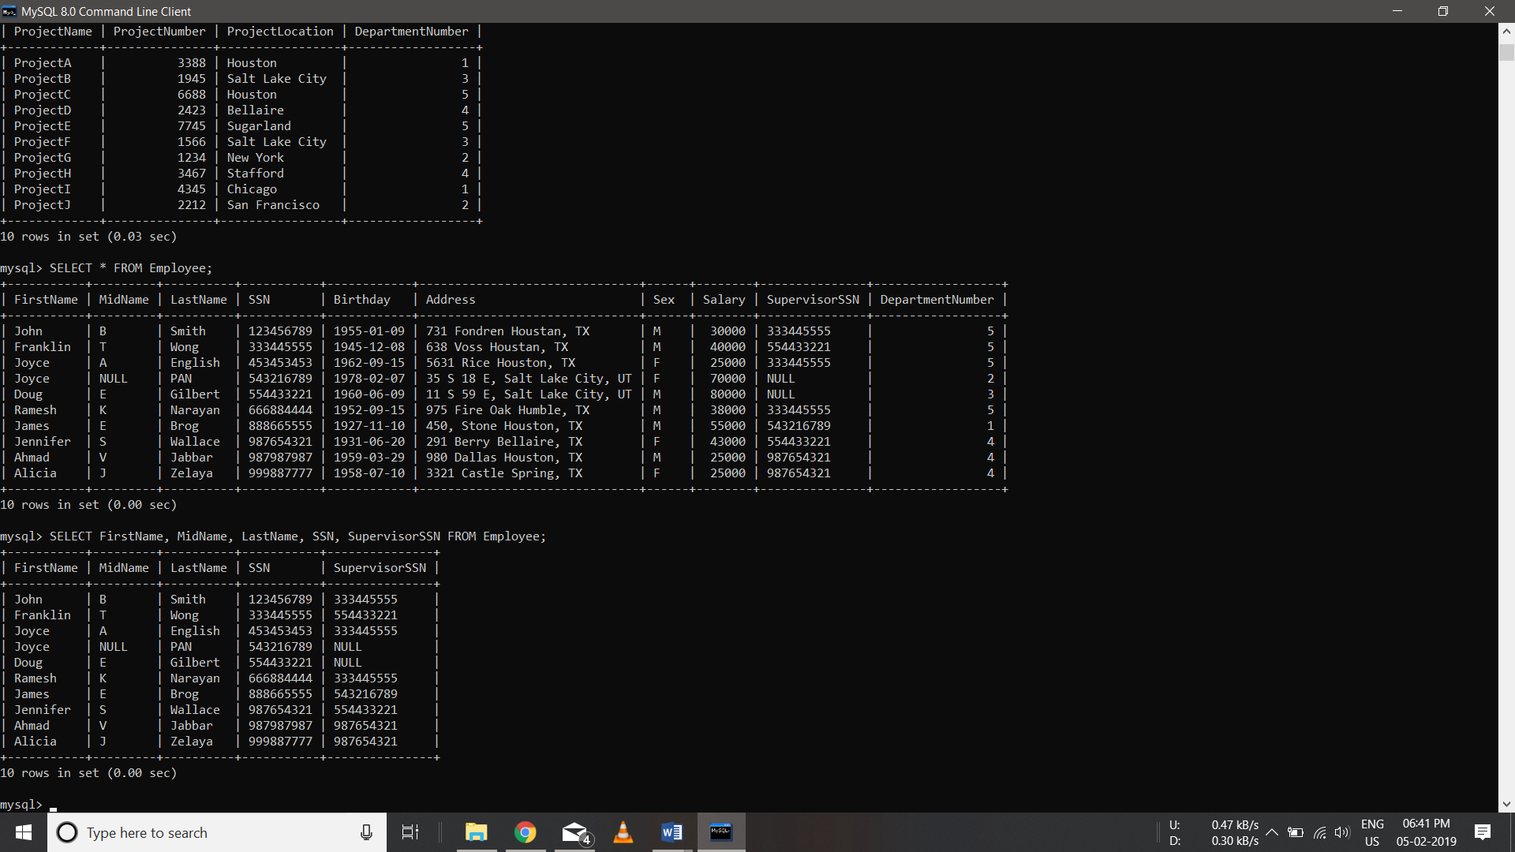

1. Alter table department add column department phone number of number data type and insert values into this column only.

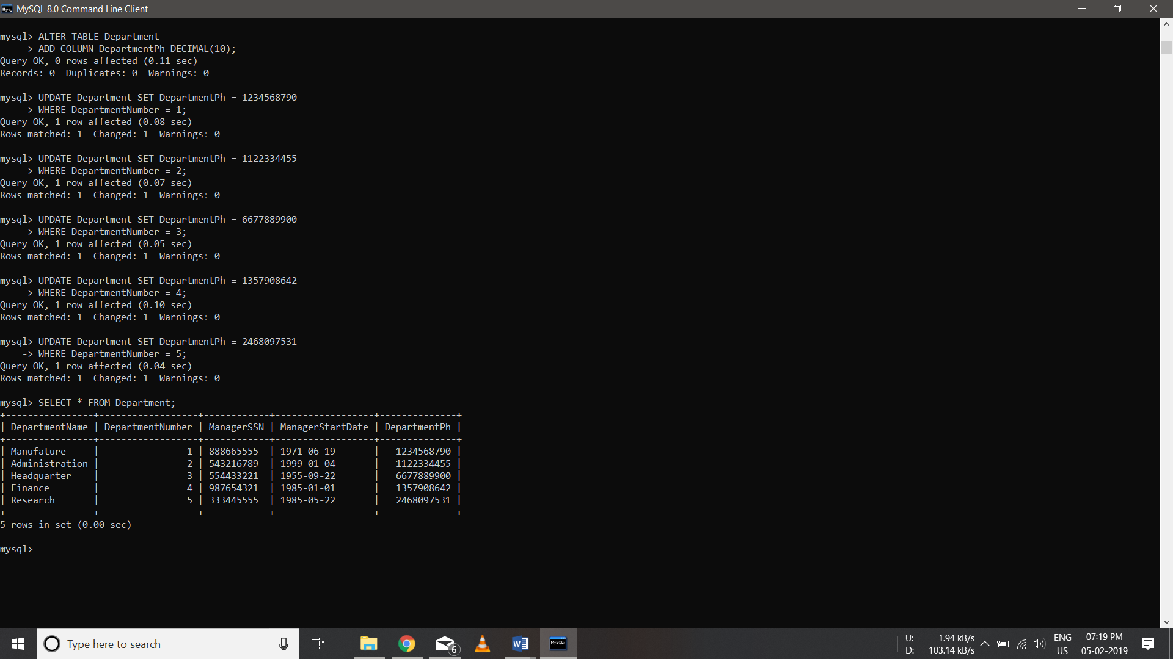

1. Modify the field name DEPARTMENTPHONENO of departments table to PHNO

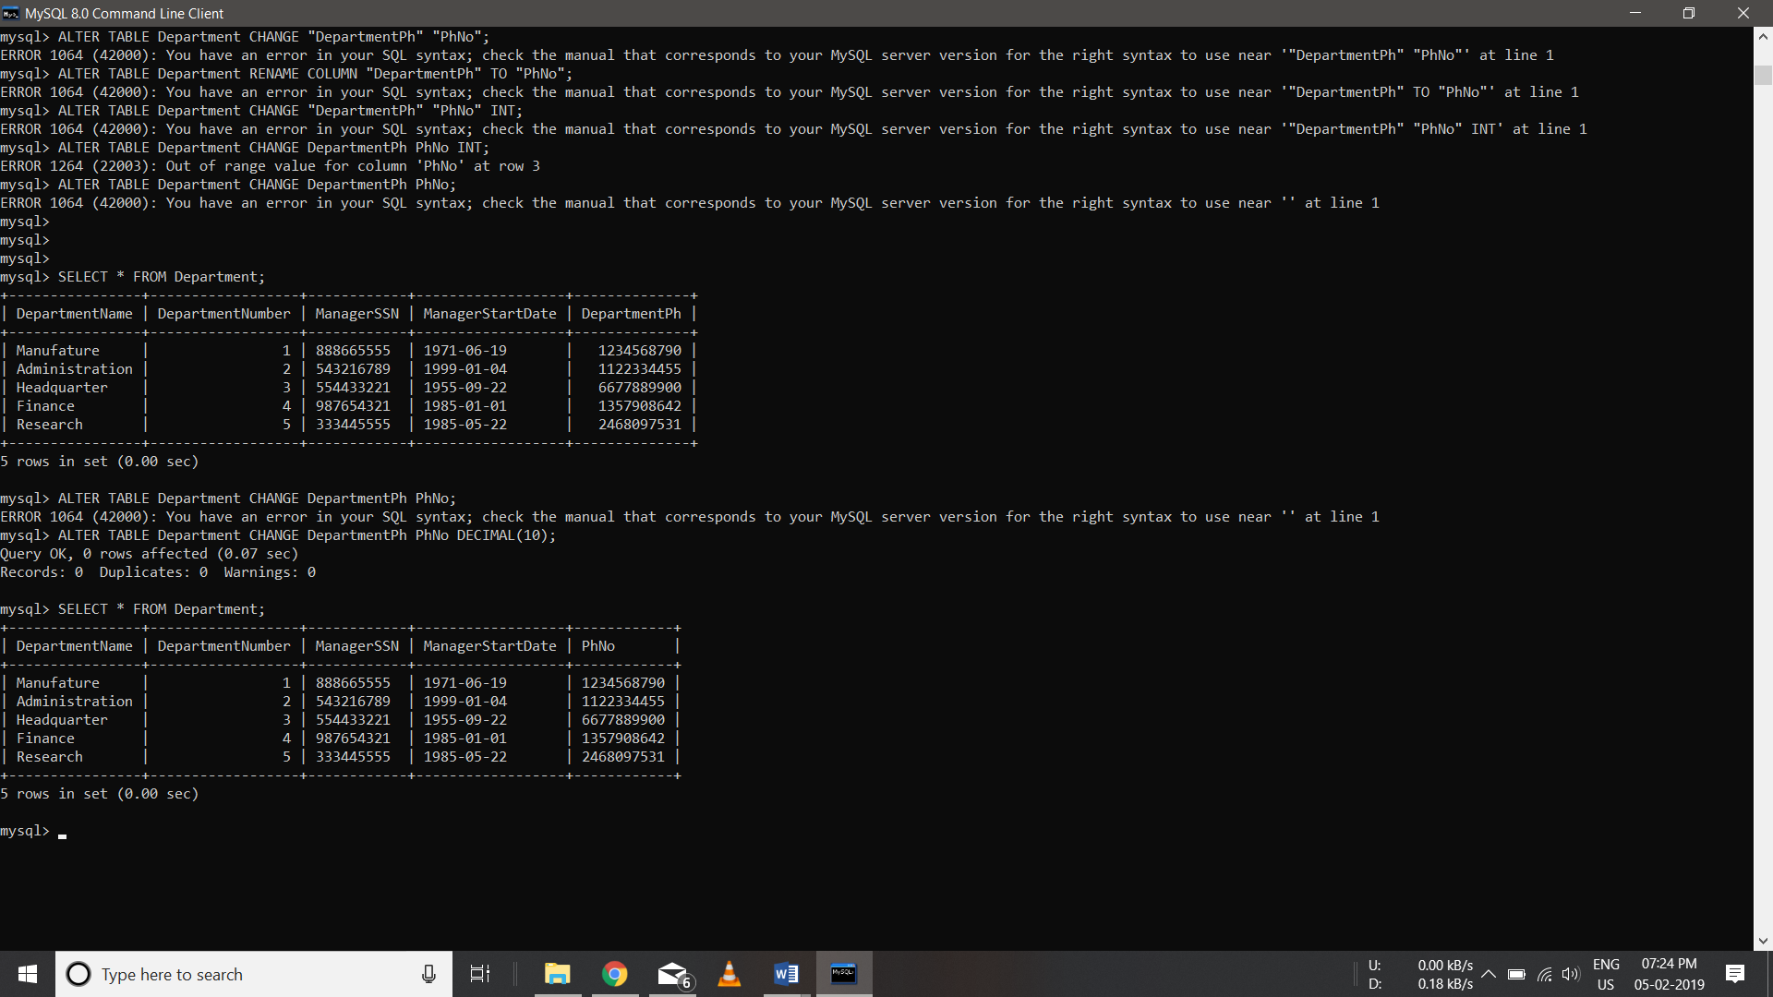

1. Rename table dept as department

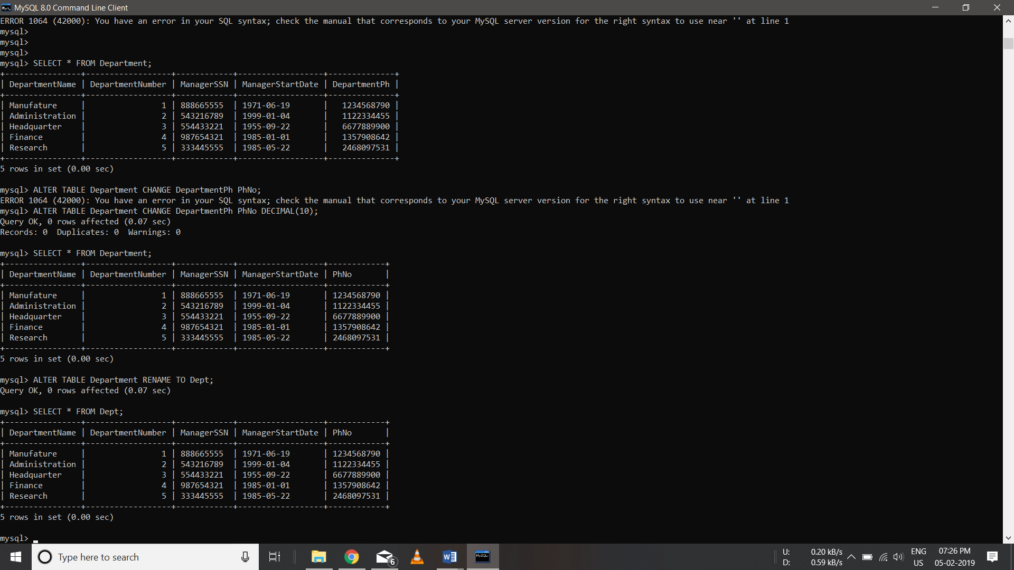

1. Alter table department remove column PHNO

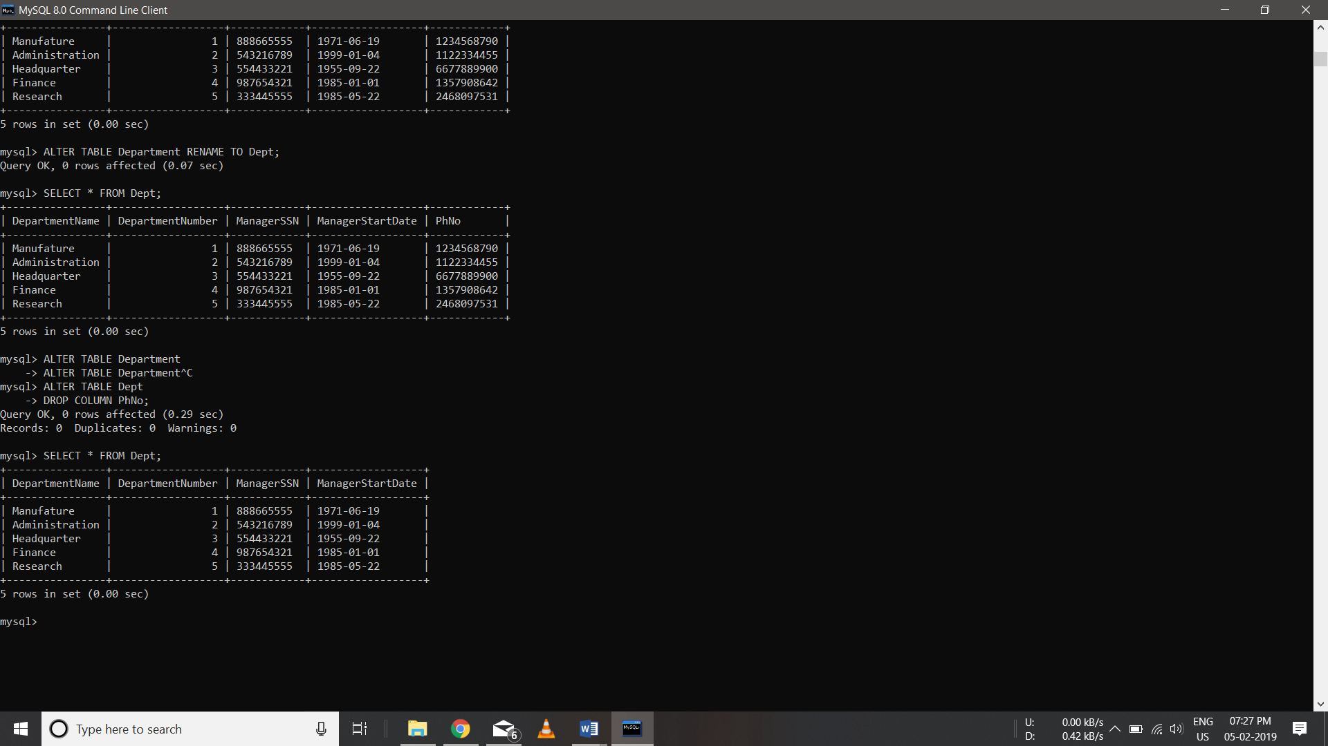

1. Create a table COPYOFDEPT as a copy of the table dept

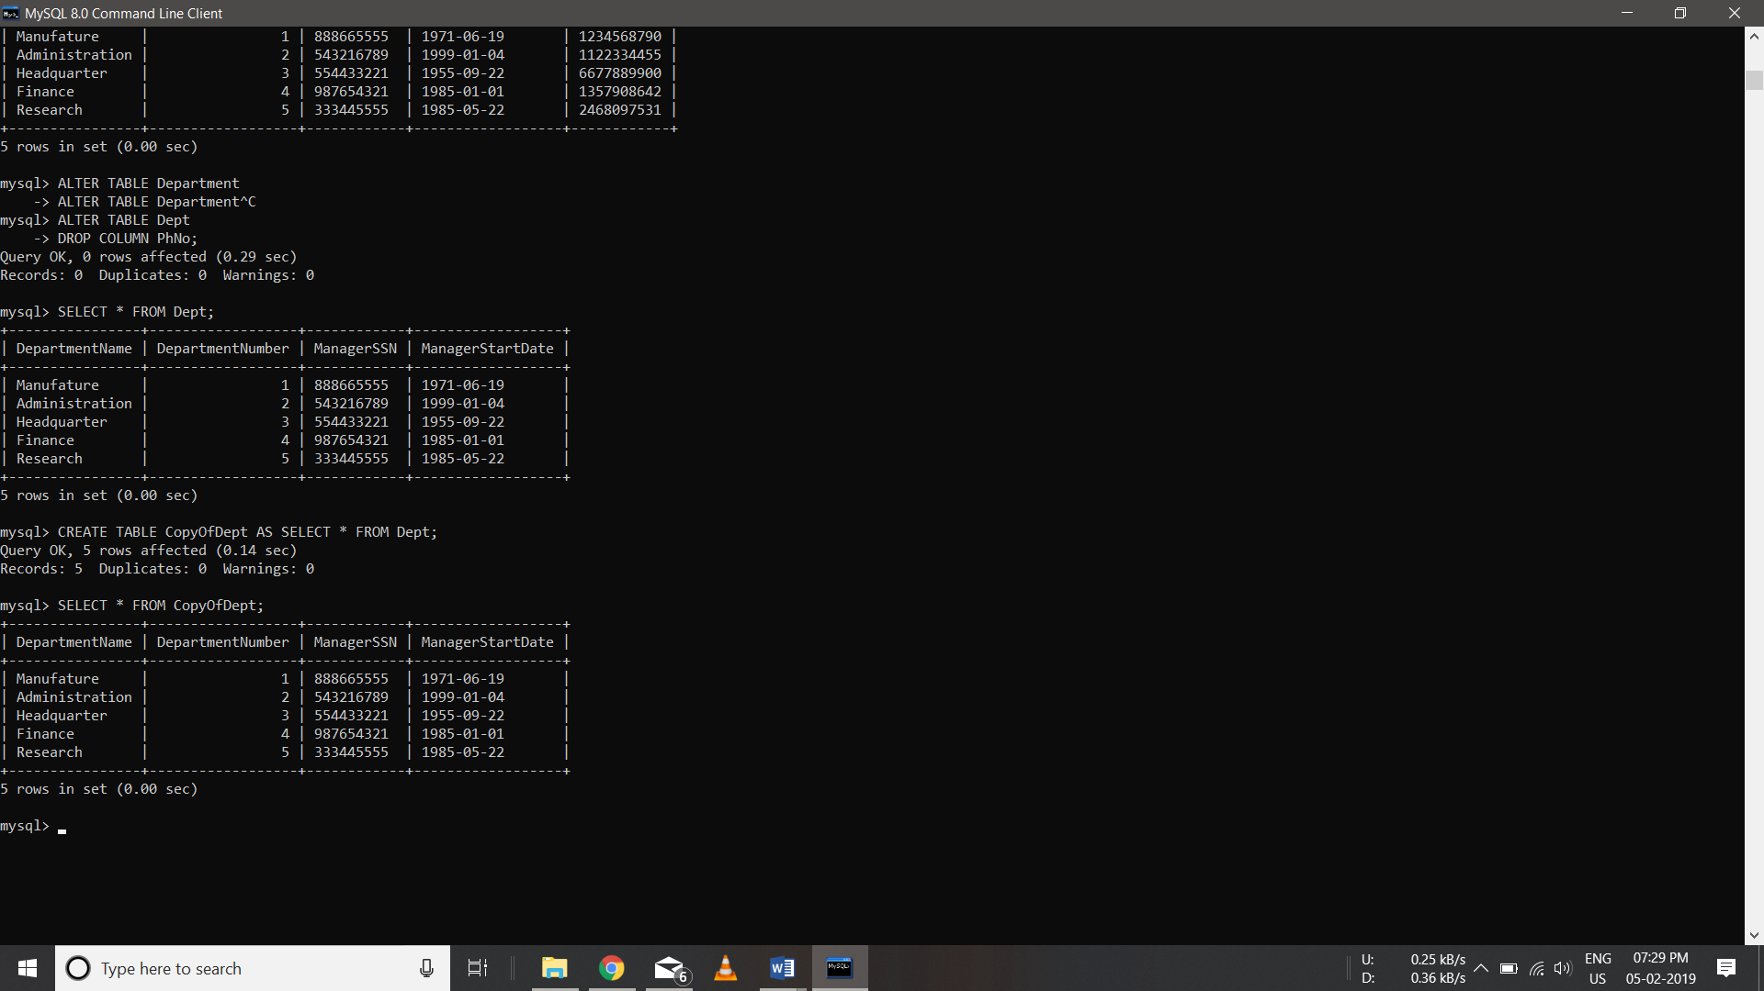

1. Delete all the rows from COPYOFDEPT table

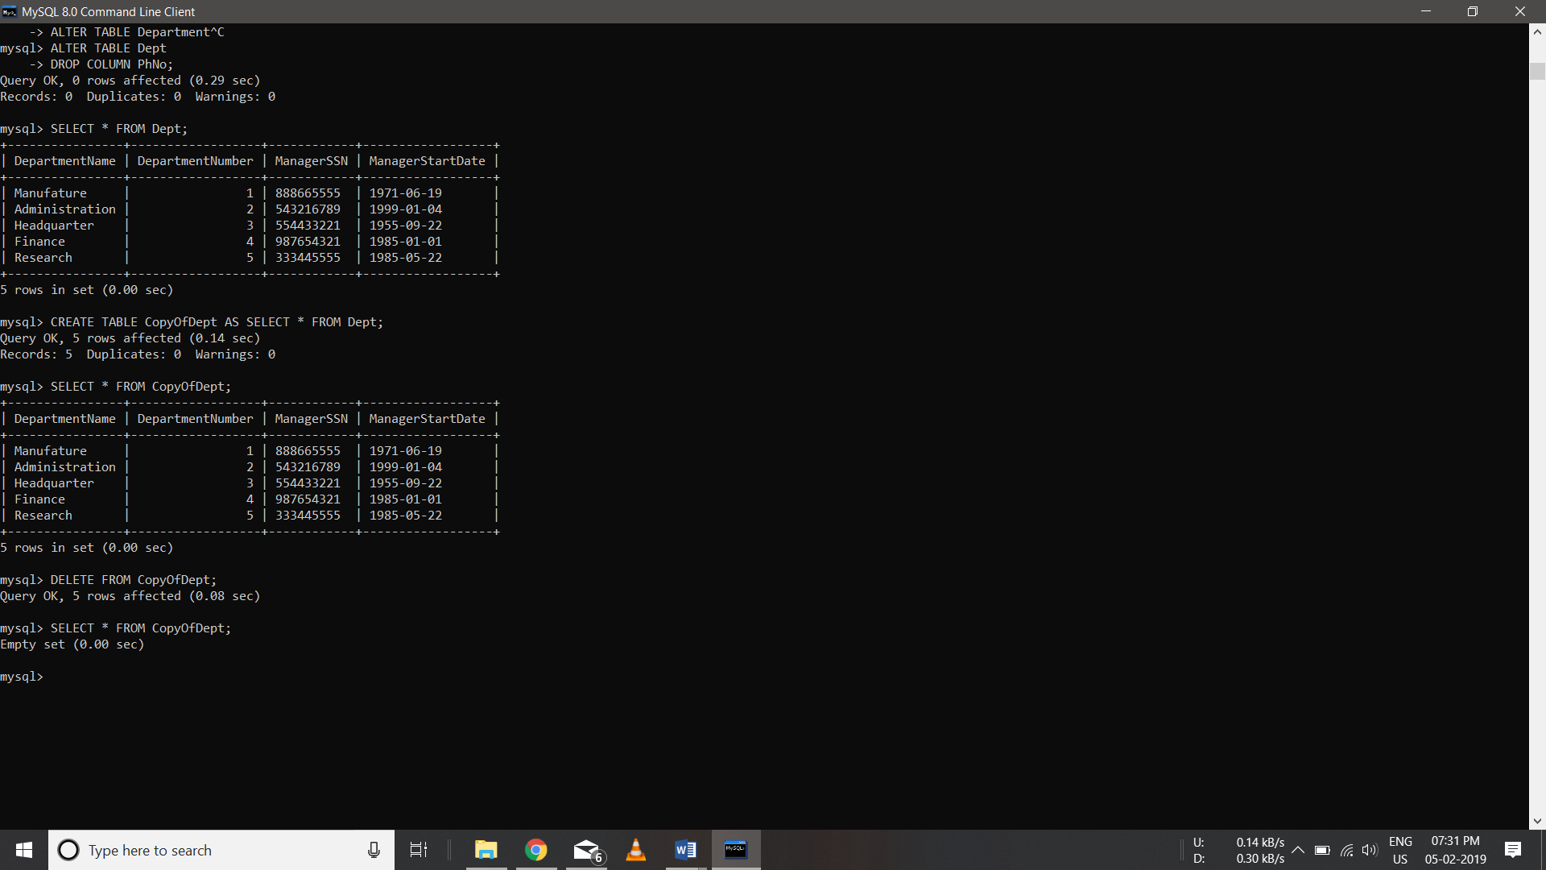

1. Remove COPYOFDEPT table

